**A GENERAL PURPOSE REAL-TIME SoC BASED MATRIX CALCULATOR**

**Project**

**ECE 5730 –Embedded System Design Using FPGAs**

**Submitted by**

**Cory Ness**

**Kokila Subramanian**

**Shivani Devatha**

**Submitted to**

**Professor Subramaniam Ganesan**



**Fall 2021**

**Table of Contents**

Abstract 3

Objective 4

System-level Block Diagram 4

Hardware Components 4

**UART-TTL Converter:** 5

**DE1-SoC FPGA Development Kit:** 7

Matrix Manipulation Theory 7

**Pseudo code for Matrix Addition:** 7

**Pseudo code for Matrix Subtraction** 7

**Pseudo code for Multiplication:** 8

**Pseudo code for Transpose of Matrix:** 9

**Pseudo code for Determinant of Matrix:** 9

Algorithm 11

**Algorithm for UART Decoder:** 11

**Algorithm for UART Transmitter:** 11

**Algorithm for FIFO:** 12

**Algorithm for Matrix Calculator:** 13

Results 14

Conclusion 15

Future improvements 15

References 16

Appendix 17

**Code** 17

**VHDL code for TOP level entity** 17

**VHDL code for UART Decoder** 18

**VHDL code for UART Transmitter:** 20

**VHDL code for FIFO:** 21

**Nios C code:** 24

Abstract

Matrix manipulation includes operations such as addition, subtraction, multiplication, inverse, and transpose etc., on the array of data stored as rows and columns. It is an essential process used in diverse fields of science and commerce including but not limited to Computer technology, Optics, Geology, Cryptography, Network Theory, Robotics and Animations, and Finance. Real-time matrix operations include a large number of computations, required for process control, and data & signal processing, which directly impacts the system performance. Real-time matrix calculation becomes a bottleneck for performance of fast system applications as it requires large computation power, memory, and time.

In this project, we present a design which can perform matrix manipulations such as addition, subtraction, scalar and matrix array multiplication, determinant of matrix, co-factor and other vital matrix operations required for real-time signal processing. The matrix manipulator is developed using Intel DE1-SoC development board with Cyclone V processor is interfaced with FT232R FTDI UART to establish serial communication between the FPGA board and PC. The matrix calculator is implemented in the NIOS II soft-core processor present on DE1-SoC board, the inputs are fed from a host computer onto FPGA board via UART serial port, a USB to TTL convertor module will be used to establish serial communication. The final computational results are fetched using the serial communication onto the remote PC.

Objective

Real-time signal processing system involves large computations and complex process control operations on massive array of data which is highly time-consuming. Currently, most of matrix operations are performed using software. The expansion of matrix dimension and reduction in processing speed has become bottleneck for the most of the existing real-time fast system applications. The objective of this project is to develop a Real-time Matrix-Manipulator using UART to TTL convertor for serial communication, Intel DE1-SoC FPGA Development Kit, and TRDB- TLM Touch screen LCD Display. The input matrix values are served into the FPGA board using Serial communication from a remote system. The matrix operations are executed in NIOS-II processor available in DE1-SoC board. The manipulated resultant matrix is displayed in the LCD display. The NIOS –II processor is used to control system operation and perform basic matrix operations such as addition, subtraction, Multiplication, finding determinant, co-factor, and other essential matrix operations required for real-time signal processing.

System-level Block Diagram

The system-level Block diagram for the Real-time Matrix Manipulator is shown in figure 1. The major functional blocks include the Remote PC, UART TTL convertor, the DE1-SoC board and the TRDB-TLM LCD display.



SDRAM

UART RX

NIOS II

Matrix Operation Algorithm

SSRAM

UART TX

UART

PIO

**USB to UART**

Serial communication

**DE1-SoC**

**PC**

**Figure 1: System-level Block Diagram**

Hardware Components

The developed Real-Time Matrix Manipulator consists of the following hardware components:

1. UART-TTL Convertor – FT232R FTDI
2. DE1-SoC Development Kit

**UART-TTL Converter:**

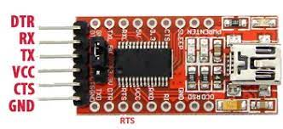

**Figure 2. FT232R FTDI USB UART**

The USB UART-TTL converter used is an FT232R FTDI (Future Technology Device International Ltd.) chip on a breakout board that simplifies serial communication by reducing the external components. Figure 2 shows the package of the USB UART. It is a fully integrated chip with 1024-bit EEPROM, clock generation, and USB termination resistors. The FT232R serial UART can support data rate transfer rates from 300 baud to 3 Mbaud at the TTL levels (FT232R, n.d.). High data throughput is achieved through the 128 bytes receive buffer and the 256 bytes transmit buffer that utilizes smooth buffer technology. The UART interface will support 7 or 8 data bits with 1 or 2 bits for representing odd, even, mark, space and non-parity bits (FT232R, n.d.). The configurable I/O pins integrated +3.3V level convertor provides output drive strength for various applications. It can be used as interface with MCU/ PLD/FPGA based designs, PDA to USB data transfer, smart card readers, Industrial control, Hardware and Wireless modems, Bar Code Readers, and Cellular Phone USB data transfer cables and interfaces ((FT232R, n.d.).

The communication is established by making use of the UART Rx and Tx lines going to pins 1 and 3 on the 20-pin expansion header of DE1-SoC board. It allows any computer to open a serial port and communicate to the DE1-SoC over a COM port, inputting the equations needed for the Matrix equations. In addition, the DE1-SoC can transmit data back to the computer by sending UART data to the FTDI board, which will display on the serial port screen for the user.

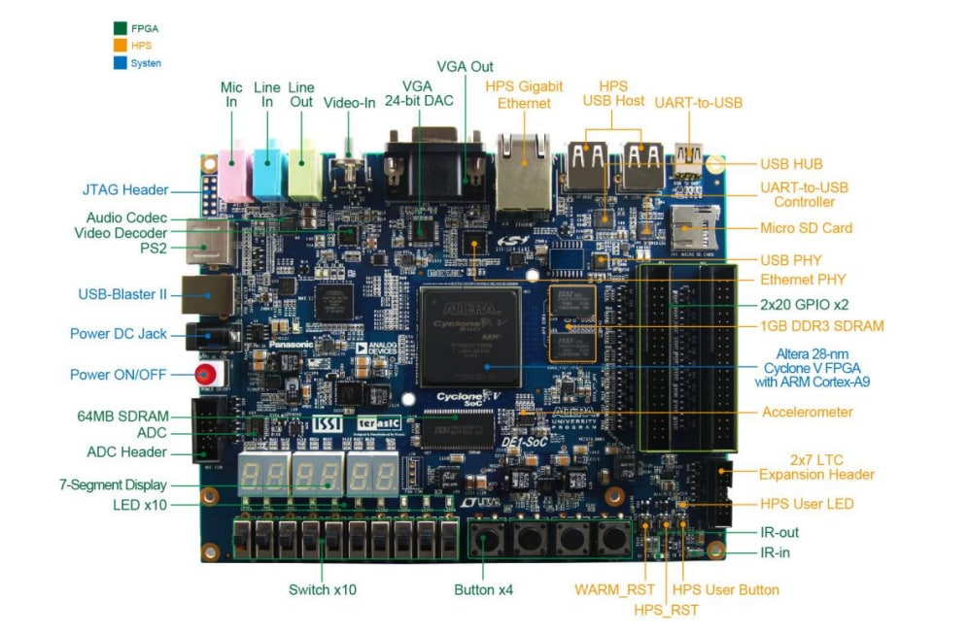**Figure 3. Altera DE1-SoC FPGA Board**

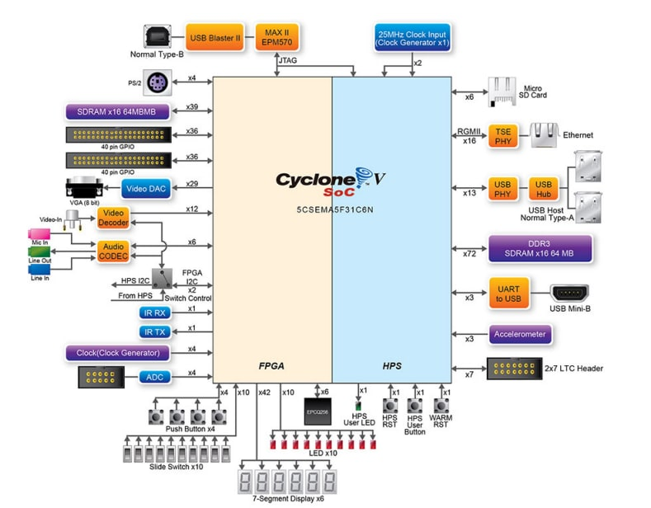

**Figure 4. Block diagram of DE1-SoC Board**

**DE1-SoC FPGA Development Kit:**

The DE1-Soc Development kit provides a hardware platform that combines the System-on Chip (SoC) FPGA and dual-core Cyclone- A9 embedded core which can be used for wide industrial application improvement. It provides users the power of flexibility in design, paired with high-processor, low-power processing system. It provides seamless integration of both SoC and ARM based hard processor system (HPS), including processor, memory and peripheral interfaces over a high-bandwidth interconnect backbone. The DE1SoC board includes hardware such as high-speed DDR3 memory, video and audio capability, Ethernet, networking and much more.

Matrix Manipulation Theory

Matrices are representation of array of data commonly used in extensive real-world data processing, research, and scientific studies. Matrix Multiplication provides good approximation for complicated calculation of real-time sensitive engineering applications signal processing, image processing, network theory and many more. Matrix manipulation is engaged with every part of day-to-day life including data base management, encryption that helps security, 3D gaming, robotics and animation, create models for economic and business, construction, physics, and geology. The common matric calculations involved are addition, subtraction, multiplication, transpose, finding the determinant value and inverse of the matrix.

**Pseudo code for Matrix Addition:**

Matrix addition can be performed only when both the matrices under operation are of same size. It is commonly employed in data, image and signal processing. The void matrix_addition() performs the following activity:

for (i=0;i<r1;i++)

{

for (j=0;j<c1;j++)

{

res[i][j]= a[i][j]+b[i][j];

}

}

**Pseudo code for Matrix Subtraction**

Matrix subtraction is a linear algebraic operation which can be performed only when both the matrices under operation are of same size. The void matrix_subraction() performs the following operation:

for (i=0;i<r1;i++)

{

for (j=0;j<c1;j++)

{

res[i][j]= a[i][j]-b[i][j];

}

}

**Pseudo code for Multiplication:**

Matrix Multiplication can be either scalar or matrix multiplication, and is the most challenging algebraic operation. Matrix multiplication can be either scalar, vector or matrix multiplication. Scalar multiplication is a element-wise multiplication of matrix elements using a real or complex value. In the below defined code, *void scalar_matrix_multiplication()* executes matrix multiplication using constant value k.

for (i=0;i<r1;i++)

{

for (j=0;j<c1;j++)

{

res[i][j] = k*a[i][j];

}

}

Multiplication of matrices can be executed under the condition that the number of rows of first matrix should be equal to number of columns in the second matrix (i.e. [A]i x j* [B]m x n = [C]i x n.

if (r1 != c2)

{

printf("Matrix multiplication cannot be performed\n");

}

else

for (i=0;i<r1;i++)

{

for (j=0;j<c2;j++)

{

res[i][j]=0;

for (k=0; k<c1;k++)

res[i][j] += a[i][k]*b[k][j];

}

}

**Pseudo code for Transpose of Matrix:**

Transpose is simply interchanging the rows and columns. It is generally employed when multiple matrix exists and the dimensions without transposing is not amendable for matrix operations. In real-time one usage of transpose is data manipulation, where the application requires the use of orthonormal matrix. In image processing switching rows and columns of pixels can result in exchanging the domain and space of the image transformation. In neural networks, frequent process weight and inputs of different sizes where the dimensions do not meet the requirement of algorithm can be accomplished using simple transpose of matrix.

for (i=0;i<c1;i++)

{

for (j=0;j<r1;j++)

{

res[i][j] = a[j][i];

}

}

**Pseudo code for Determinant of Matrix:**

Determinant is the number associated with square matrix that encodes information about the matrix. Determinant of matrix is used to check the consistency of any system and to solve linear equations.

for (int f = 0; f < n; f++)

{

// Getting Cofactor of a[0][f]

temp= malloc(2*sizeof*temp);

for (i=0; i< 2; i++)

{

temp[i]= malloc(2*sizeof*temp[i]);

}

i=0;

// Looping for each element of the matrix

for (int row = 0; row < n; row++)

{

for (int col = 0; col < n; col++)

{

// Copying into temporary matrix only those

// element which are not in given row and

// column

if (row != 0 && col != f)

{

temp[i][j++] = a[row][col];

// Row is filled, so increase row index and

// reset col index

if (j == n - 1)

{

j = 0;

i++;

}

}

}

}

if(f%2==0)

{

(D += a[0][f]*(matrix_det(temp, n - 1,n - 1)));

}

else

{

D -= a[0][f]*(matrix_det(temp, n - 1,n - 1));

}

// terms are to be added with alternate sign

D1=D;

Algorithm

**Algorithm for UART Decoder:**

The UART Decoder accepts 2 inputs and has 2 outputs. The first input is Clk, with a frequency set by the generic variable ClockRate. The second input is Rx, which is the pin state of the UART Rx pin. The first output is Complete, a single bit that is low while receiving Uart data and high once the Uart byte is fully decoded. The second output is Data, an 8-bit vector that is decoded value from the Rx pin. The VHDL code for the UART decoder works as follows:

1. Input the clock rate and baud rate using the generic map, as this will not change throughout operation.
2. Wait for the start-bit from UART Rx (High->Low Transition).
3. Begin counting the clock cycles until we reach the necessary baud rate.
4. Halfway-through the count, sample the Rx line and save it in data_register, this ensures we sample when the data line is stable.
5. Once the count reaches the baud value, reset the count
6. Repeat until all 10 bits have been sampled (start bit, data bits, stop bit).
7. Once all bits have been sampled, set the Complete signal to indicate Data is stable
8. Wait for next start-bit.

This isn’t sufficient, however, for the NIOS processor to use, since it will stream all the data in immediately. We can make use of interrupts inside the NIOS processor to react whenever the Complete signal rises, but it will take time away from performing calculations. We decided to make use of the decoder by also implementing a FIFO (First In First Out) buffer, which will buffer in up to 128 bytes of UART data to be read out by the NIOS processor when it’s ready.

**Algorithm for UART Transmitter:**

The VHDL code for the UART transmitter is very similar to the Decoder, but in reverse. It has 3 inputs and a single output. The first input is Clk, the system clock with frequency specified in the generic ClockRate. The second input is Send, a single bit that triggers the send sequence on a low to high transition. The third input is Data, an 8-bit vector that is the value to send over UART. It also has a single output, Tx, which should be tied to the Tx pin on the DE1 board. The transmitter works as follows:

1. Input clock rate and baud rate using generic map, as this will not change throughout operation
2. Wait for low->high transition on Send input
3. Bring Tx low, and begin counting clock cycles until we reach necessary baud rate
4. Once the count has rolled over, change the Tx state based on the bit of Data
5. Repeat until all 8 data bits have been sent
6. Bring Tx high to send the stop bit.
7. Reset all variables back to original states and wait for next low->high transition.

Following this we can control the transmitter tying a parallel IO in the NIOS processor to send the start signal, and the data can be tied to another parallel IO. The Clk and Tx bits are tied to the 50 Mhz clock and UART Tx pin respectively, and this is everything necessary to integrate a UART transmitter into our NIOS design.

**Algorithm for FIFO:**

The VHDL code for the FIFO is very simple and elegant. It uses 4 inputs and 1 output. The first input is complete, which indicates that data is complete and ready to be pushed into the FIFO. The next is data_in, an 8 bit vector that is the data to be pushed in. The third is pop, which will pop out the data and point data_out to the next data to be sent out. The final input is clear, which clears and resets the FIFO so that it’s as if it had just started. The only output of the FIFO is data_out, an 8-bit vector that is the data to be sent out. The operation for the FIFO is very simple, first configure the generic num to the amount of data you want to buffer. Then, tie the data_in signal to some data you want buffered, and whenever you press complete, it will be buffered into the FIFO. Meanwhile, data_out is always the oldest data in the buffer, and you can point data_out to the next oldest data by pressing pop. Clear can be tied to a debug pin so that you can manually clear the FIFO during development. The process for the FIFO is as follows:

1. Configure the depth of the FIFO with the num generic value
2. Wait for low->high transition on the complete input or pop input or clear input
3. If low->high on complete…
   1. Copy data_in into the mem (an array of size num of 8-bit vectors) signal at location start
   2. Increment start by one
4. If low->high on pop…
   1. Increment stop by one
5. If low->high on clear…
   1. Set start and stop both to 0
6. Check if start is equal to stop
7. If yes…
   1. Output “00000000”
8. Otherwise…
   1. Output the value in mem at location stop

**Algorithm for Matrix Calculator:**

The NIOS C code for calculator can read matrix of any order and can implement addition, subtraction, multiplication, transpose and also calculates determinant. Order of two matrices, values into two matrices and type of operation needs to be entered into a FIFO and when C code is built and run, the values are fetched into rows, columns and as elements of two matrices. The row and column sizes are dynamically allocated. So, there is no restriction on the order of the matrices. The process is as follows:

1. Inside main, declare variables that store row and column numbers of two matrices, chooses type of operation, array elements
2. Values into variables are read by decoding the values from parallel IO, which in turn fetches the value from FIFO
3. A function is used to indicate next value from parallel IO to be read
4. Based on the operation selected, the corresponding C function is called
5. Matrix operation is performed, and result is written into a parallel IO which is connected UART Tx and the results are displayed on the remote terminal

Results

Case 1: Two matrices of order (1,1)

A(1,1)=10; B(1,1)=10

Option selected: Addition

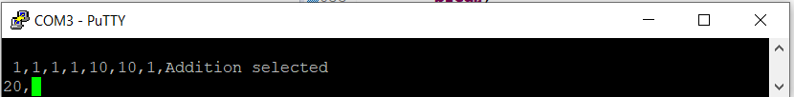

Output: Sum of 10+10 = 20

Case 2: Two matrices of order(1,1)

A(1,1)=10;B(1,1)=20;

Option selected: Determinant

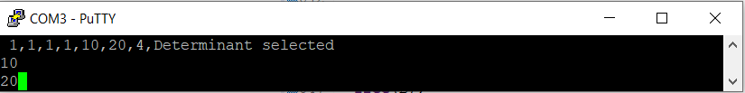

Output: Determinant of matrix A is 10; Determinant of matrix B is 20

Case 3: Two matrices of order(3,3)

A(3,3)=1,0,0;0,1,0;0,0,1;B(3,3)=2,0,0;0,2,0;0,0,2;

Option selected: Determinant

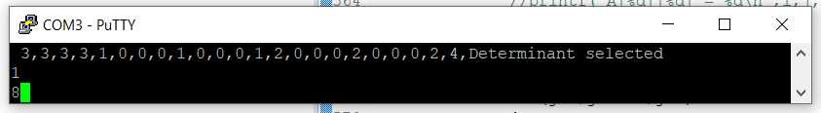

Output: Determinant of matrix A is 1; Determinant of matrix B is 8

Conclusion

Primary goal to use Nios II soft core processor and establish UART communication with USB to TTL converter interface is successfully achieved. There is no constraint on the amount of input data that can be read using UART within the hardware capability.

Future improvements

1. The matrix operations can be made generic to deal with different formats of data like float, double etc
2. The speed of UART Rx and Tx can be improved, the decoder can be made more robust to read large amount of data correctly
3. Extensive validation of the code was not feasible within the project timeline

References

1. *Future Technology Devices International LTD FT232R USB ...* (n.d.). <https://ftdichip.com/wp-content/uploads/2020/08/DS_FT232R.pdf>.
2. *DE1-SoC User Manual.*

[*https://www.intel.com/content/dam/altera-www/global/en_US/portal/dsn/42/doc-us-dsnbk-42-1004282204-de1-soc-user-manual.pdf*](https://www.intel.com/content/dam/altera-www/global/en_US/portal/dsn/42/doc-us-dsnbk-42-1004282204-de1-soc-user-manual.pdf)

1. *Nios-II software development.*

[*https://www.uio.no/studier/emner/matnat/fys/FYS4220/h20/lecture-slides/embedded_niosii_sw_dev.pdf*](https://www.uio.no/studier/emner/matnat/fys/FYS4220/h20/lecture-slides/embedded_niosii_sw_dev.pdf)

Appendix

**Code**

**VHDL code for TOP level entity**

library IEEE;

use IEEE.std_logic_1164.all;

use IEEE.numeric_std.all;

entity MATRIX_CALCULATOR is

port (

CLOCK_50 : in std_logic := '0'; -- clk.clk

UART_RX : in std_logic;

SW : in std_logic_vector(9 downto 0);

UART_TX : out std_logic;

LEDR : out std_logic_vector(9 downto 0)

);

end entity MATRIX_CALCULATOR;

architecture Behavior of MATRIX_CALCULATOR is

signal next_write : std_logic_vector(7 downto 0);

signal toWrite : std_logic_vector(7 downto 0);

signal next_read : std_logic_vector(7 downto 0);

signal toRead : std_logic_vector(7 downto 0);

signal gotUart : std_logic;

signal decodedRead: std_logic_vector(7 downto 0);

component MATRIX_CALCULATOR_sys is

port (

clk_clk : in std_logic := '0'; -- clk.clk

nextval_external_connection_export : out std_logic_vector(7 downto 0); -- nextval_external_connection.export

nextwriteval_external_connection_export : out std_logic_vector(7 downto 0); -- nextwriteval_external_connection.export

readval_external_connection_export : in std_logic_vector(7 downto 0) := (others => '0'); -- readval_external_connection.export

writeval_external_connection_export : out std_logic_vector(7 downto 0) -- writeval_external_connection.export

);

end component;

begin

calculator : MATRIX_CALCULATOR_sys port map (CLOCK_50, next_read, next_write, toRead, toWrite);

uart_decoder : entity work.Uart_Decoder port map (CLOCK_50, UART_RX, gotUart, decodedRead);

uart_transmitter : entity work.Uart_Transmitter port map (CLOCK_50, next_write(0), toWrite, UART_TX);

read_fifo : entity work.FIFO generic map (128) port map (gotUart, decodedRead, next_read(0), SW(0), toRead);

LEDR(7 downto 0) <= toRead;

end Behavior;

**VHDL code for UART Decoder**

LIBRARY ieee;

USE ieee.std_logic_1164.all;

USE ieee.numeric_std.all;

ENTITY Uart_Decoder IS

GENERIC(

BaudRate : IN INTEGER := 9600;

ClockRate : IN INTEGER := 50_000_000

);

PORT(

Clk, Rx : IN STD_LOGIC;

Complete : OUT STD_LOGIC;

Data : OUT STD_LOGIC_VECTOR(7 DOWNTO 0)

);

END Uart_Decoder;

ARCHITECTURE Behavior OF Uart_Decoder IS

SIGNAL started : STD_LOGIC; -- Whether we've started or not

SIGNAL bit_location : Integer RANGE 0 TO 9 := 0; -- Where to save the bit

SIGNAL data_reg : STD_LOGIC_VECTOR(9 DOWNTO 0); -- Local copy of the data, including start and stop bit

BEGIN

PROCESS (Rx, bit_location)

BEGIN

IF bit_location = 9 THEN

started <= '0';

ELSIF Rx = '0' AND Rx'event THEN

started <= '1';

END IF;

END PROCESS;

PROCESS (Clk, Rx, started)

VARIABLE counter : Integer RANGE 0 TO ((ClockRate / BaudRate)+1) := 0;

BEGIN

IF Clk = '1' AND Clk'event THEN

IF started = '1' THEN

counter := counter + 1;

IF counter = ((ClockRate) / BaudRate) THEN

counter := 0;

bit_location <= bit_location + 1;

ELSIF counter = (ClockRate / (BaudRate * 2)) THEN

data_reg(bit_location) <= Rx;

END IF;

ELSE

bit_location <= 0;

counter := 0;

END IF;

END IF;

END PROCESS;

Complete <= NOT started;

Data <= data_reg(8 DOWNTO 1);

END Behavior;

**VHDL code for UART Transmitter:**

LIBRARY ieee;

USE ieee.std_logic_1164.all;

USE ieee.numeric_std.all;

ENTITY Uart_Transmitter IS

GENERIC(

BaudRate : IN INTEGER := 9600;

ClockRate : IN INTEGER := 50_000_000

);

PORT(

Clk, Send : IN STD_LOGIC;

Data : IN STD_LOGIC_VECTOR(7 DOWNTO 0);

Tx : OUT STD_LOGIC

);

END Uart_Transmitter;

ARCHITECTURE Behavior OF Uart_Transmitter IS

SIGNAL started : STD_LOGIC; -- Whether we've started or not

SIGNAL bit_location : Integer RANGE 0 TO 9 := 0; -- Where to save the bit

BEGIN

PROCESS (Send, bit_location)

BEGIN

IF bit_location = 9 THEN

started <= '0';

ELSIF Send = '1' AND Send'event THEN

started <= '1';

END IF;

END PROCESS;

PROCESS (Clk, started, Data)

VARIABLE counter : Integer RANGE 0 TO ((ClockRate*2) / BaudRate) := 0;

BEGIN

IF Clk = '1' AND Clk'event THEN

IF started = '1' THEN

counter := counter + 1;

IF counter = ((ClockRate) / BaudRate) THEN

counter := 0;

bit_location <= bit_location + 1;

ELSIF counter = (ClockRate / (BaudRate*2)) THEN

-- Send the start bit

IF(bit_location = 0) THEN

Tx <= '0';

-- Send data bits

ELSIF bit_location > 0 AND bit_location < 9 THEN

Tx <= Data(bit_location - 1);

-- Send the stop bit

ELSE

Tx <= '1';

END IF;

END IF;

ELSE

bit_location <= 0;

counter := 0;

Tx <= '1';

END IF;

END IF;

END PROCESS;

END Behavior;

**VHDL code for FIFO:**

library IEEE;

use IEEE.STD_LOGIC_1164.ALL;

use IEEE.STD_LOGIC_UNSIGNED.ALL;

entity FIFO is

generic (num : in integer := 128);

port ( complete : in std_logic;

data_in : in std_logic_vector(7 downto 0);

pop, clear : in std_logic;

data_out : out std_logic_vector (7 downto 0));

end FIFO;

architecture behavior of FIFO is

type fifo_size is array (0 to num-1) of std_logic_vector (7 downto 0);

signal mem : fifo_size; --declaring 32 buffers with 8 bit wide

signal stop : integer range 0 to num-1 := 0;

signal start : integer range 0 to num-1 := 0;

begin

--at the rising edge of complete

--data is received into buffer

--if index of mem reaches num (32) the index is changed ot 0

process(complete, pop, data_in, clear)

variable newStart : integer range 0 to num-1;

variable newEnd : integer range 0 to num-1;

variable toSend : std_logic_vector(7 downto 0);

begin

if clear = '1' then

start <= 0;

stop <= 0;

else

if complete'event and complete = '1' then

newEnd := stop - 2;

if not(start = newEnd) then

start <= start + 1;

if(start = num-1) then

mem(0) <= data_in;

else

mem(start + 1) <= data_in;

end if;

end if;

end if;

--assuming pop as a 1 bit input

--first value from the queue is stored into data_out object

--queue is updated

newStart := start;

if pop'event and pop = '1' then

if not (newStart = stop) then

stop <= stop + 1;

end if;

end if;

end if;

-- Get the current head of the ring buffer if we're not empty

if not (start = stop) then

if(stop = num - 1) then

toSend := mem(0);

else

toSend := mem(stop + 1);

end if;

else

toSend := "00000000";

end if;

data_out <= toSend;

end process;

end;

**Nios C code:**

//declaration of header files

#include "sys/alt_stdio.h"

#include "stdlib.h"

#include "stdio.h"

#include "math.h"

#include "stdint.h"

#include "io.h"

#include "altera_avalon_pio_regs.h"

#include "string.h"

/**

**@brief – sends an indicator to UART Tx that next value is ready to be displayed on the terminal

*/

void next_write()

{

uint8_t *next;

next = (uint8_t *)0x00021000;

*next = 0;

for(volatile uint32_t i=0; i<500000;i++);

*next = 1;

for(volatile uint32_t i=0; i<500000;i++);

}

/**

**@brief – writeByte and writeString functions fetch the value to be displayed into a Parallel IO with address 0x00021010

*the value from the parallel IO is sent to UART Tx to display on the remote terminal

*/

void writeByte(char c)

{

char *toSend;

toSend = (char *)0x00021010;

*toSend = c;

}

void writeString(char* str, int len)

{

for(int i = 0; i < len; ++i) {

writeByte(str[i]);

next_write();

}

}

/**

**@brief – sends an indicator to FIFO that next value is ready to be stored into a parallel IO

*/

void next_from_pio()

{

uint8_t *next;

next = (uint8_t *)0x00021020;

*next = 0;

for(volatile uint32_t i=0; i<500000;i++);

*next = 1;

for(volatile uint32_t i=0; i<500000;i++);

}

/**

**@brief – decodes the ascii value present in the Parallel IO( with address -0x00021030) into a number

*calls next_from_pio() function inorder to store new value from FIFO into Parallel IO

*‘,’ (comma) is used as a delimiter while reading data from FIFO

*/

int decode_ascii() {

int retval = 0;

while(1) {

char value = IORD_ALTERA_AVALON_PIO_DATA(0x00021030);

printf("%c\n", value);

if(value == ',') break;

if(value >= '0' && value <= '9')

{

retval *= 10;

retval += value-'0';

}

next_from_pio();

}

next_from_pio();

return retval;

}

/*

/**

* @brief Adds to matrices together

*

* @param a First matrix to add

* @param b Second matrix to add

* @param r1 Number of rows in a

* @param c1 Number of columns in a

* @param r2 Number of rows in b

* @param c2 Number of columns in b

*/

void matrix_add(int** a, int** b, int r1, int c1, int r2, int c2)

{

int i,j,k,l;

int res[r1][c1];

if (r1 != r2 || c2 != c1)

{

char s[100];

char disp[]="Cannot be added";

sprintf(s,"%s",disp);

writeString(s, strlen(s));

}

else

{

for (i=0;i<r1;i++)

{

for(j=0;j<c1;j++)

{

res[i][j]= a[i][j] + b[i][j];

}

}

}

for (i=0;i<r1;i++)

{

for(j=0;j<c1;j++)

{

printf("res[%d][%d]= %d\n",i,j,res[i][j]);

char s[100];

sprintf(s,"%d,",res[i][j]);

writeString(s, strlen(s));

}

}

}

/**

* @brief performs matrix subtraction

*

* @param a First matrix

* @param b Second matrix

* @param r1 Number of rows in a

* @param c1 Number of columns in a

* @param r2 Number of rows in b

* @param c2 Number of columns in b

*/

void matrix_sub(int** a, int** b, int r1, int c1, int r2, int c2)

{

int i,j,k,l;

int res[r1][c1];

if (r1 != r2 || c2 != c1)

{

char s[100];

char disp[]="Cannot be subtracted";

sprintf(s,"%s",disp);

writeString(s, sizeof(s));

}

else

{

for (i=0;i<r1;i++)

{

for(j=0;j<c1;j++)

{

res[i][j]= a[i][j] - b[i][j];

}

}

}

for (i=0;i<r1;i++)

{

for(j=0;j<c1;j++)

{

printf("res[%d][%d]= %d\n",i,j,res[i][j]);

char s[100];

sprintf(s,"%d,",res[i][j]);

writeString(s, strlen(s));

}}}

/**

* @brief Multiplies two matrices together

*

* @param a First matrix

* @param b Second matrix

* @param r1 Number of rows in a

* @param c1 Number of columns in a

* @param r2 Number of rows in b

* @param c2 Number of columns in b

*/

void matrix_mul(int** a, int** b, int r1, int c1, int r2, int c2)

{

int i,j,k,l,m;

int res[r1][c2];

if(c1 != r2)

{

char s[100];

char disp[]="Cannot be multiplied";

sprintf(s,"%s",disp);

writeString(s, sizeof(s));

}

else

{

for (i=0;i<r1;i++)

{

for(j=0;j<c2;j++)

{

res[i][j]=0;

for(m=0;m<c1;m++)

{

res[i][j]=res[i][j]+ (a[i][m] * b[m][j]);

}

}

}

}

for (i=0;i<r1;i++)

{

for(j=0;j<c2;j++)

{

printf("res[%d][%d]= %d",i,j,res[i][j]);

char s[100];

sprintf(s,"%d,",res[i][j]);

writeString(s, strlen(s));

}}}

/*scalar multiplication*/

void scalar_matrix_mul (int **a, int r1, int c1)

{

int i,j;

int k;

int res[r1][c1];

for (i=0; i<r1; i++)

{

for (j=0;j<c1;j++)

{

res[i][j]=k*a[i][j];

}

}

for (i=0;i<r1;i++)

{

for(j=0;j<c1;j++)

{

printf("res[%d][%d]= %d\n",i,j,res[i][j]);

char s[100];

sprintf(s,"%d,",res[i][j]);

writeString(s, strlen(s));

}}}

/**

* @brief Calculates determinant of a matrix

*

* @param a First matrix whose determinant is calculated

* @param r1 Number of rows in a

* @param c1 Number of columns in a

*/

int matrix_det(int** a, int r1, int c1)

{

int D ;

int D1;

int n;

int **temp;

int i,j=0;

int sign = 1;

// Base case : if matrix contains single element

if(r1!=c1)

{

//not possible to find determinant

char s[100];

char disp[]="Cannot find determinant";

sprintf(s,"%s",disp);

writeString(s, strlen(s));

}

else

{

n=r1;

if (n == 1)

{

D=a[0][0];

return(D);

}

else

{

D=0;

// Iterate for each element of first row

for (int f = 0; f < n; f++)

{

// Getting Cofactor of a[0][f]

temp= malloc(2*sizeof*temp);

for (i=0; i< n; i++)

{

temp[i]= malloc(2*sizeof*temp[i]);

}

i=0;

// Looping for each element of the matrix

for (int row = 0; row < n; row++)

{

for (int col = 0; col < n; col++)

{

// Copying into temporary matrix only those

// element which are not in given row and

// column

if (row != 0 && col != f)

{

temp[i][j++] = a[row][col];

// Row is filled, so increase row index and

// reset col index

if (j == n - 1)

{

j = 0;

i++;

}

}

}

}

if(f%2==0)

{

( D += a[0][f]

*(matrix_det(temp, n - 1,n - 1)));

}

else

{

D -= a[0][f]

*(matrix_det(temp, n - 1,n - 1));

}

// terms are to be added with alternate sign

D1=D;

}

}

}

return D1;}

/**

* @brief Calculates transpose of a matrix

*

* @param a is the matrix whose transpose is calculated

* @param r1 Number of rows in a

* @param c1 Number of columns in a

*/

void matrix_transpose(int **a, int r1, int c1)

{

int i,j;

int res[r1][c1];

for (i=0; i<c1;i++)

{

for (j=0;j<r1;j++)

{

res[i][j]= a[j][i];

}

}

for (i=0;i<c1;i++)

{

for(j=0;j<r1;j++)

{

printf("res[%d][%d]= %d\n",i,j,res[i][j]);

char s[100];

sprintf(s,"%d,",res[i][j]);

writeString(s, strlen(s));

}}}

/*......Main Program ........*/

int main()

{

int ROW1, ROW2, COL1, COL2;

int **A;

int **B ;

int Determinant_A,Determinant_B;

int OP_SEL;

char str[100];

int i,j,k;

printf("entered main\n");

//reading row and column size for matrix A and B

// Read the row, column size of matrix 1 and matrix 2 from the FPGA PIO layer.

ROW1= decode_ascii();

COL1=decode_ascii();

ROW2=decode_ascii();

COL2=decode_ascii();

//reading values into matrix A and B

//allocating memory

A= malloc(ROW1*sizeof*A);

for (i=0; i< ROW1; i++)

{

A[i]= malloc(COL1*sizeof*A[i]);

}

B= malloc(ROW2*sizeof*B);

for (i=0; i< ROW2; i++)

{

B[i]= malloc(COL2*sizeof*B[i]);

}

for (i=0;i<ROW1; i++)

{

for(j=0;j<COL1;j++)

{

A[i][j]=decode_ascii();

}

}

for (i=0;i<ROW2; i++)

{

for(j=0;j<COL2;j++)

{

B[i][j]=decode_ascii();

} }

printf("ROW1=%d\n",ROW1);

printf("COL1=%d\n",COL1);

printf("ROW2=%d\n",ROW2);

printf("COL2=%d\n",COL2);

//reading valaue that indicates type of operation

OP_SEL=decode_ascii();

printf("%d\n",OP_SEL);

switch (OP_SEL){

case 1:

writeString("Addition selected\r\n",strlen("Addition selected\r\n"));

matrix_add(A,B,ROW1,COL1, ROW2,COL2);

break;

case 2:

writeString("Subtraction selected\r\n",strlen("Subtraction selected\r\n"));

matrix_sub(A,B,ROW1,COL1, ROW2,COL2);

break;

case 3:

writeString("Multiplication selected\r\n",strlen("Multiplication selected\r\n"));

matrix_mul(A,B,ROW1,COL1, ROW2,COL2);

break;

case 4:

writeString("Determinant selected\r\n",strlen("Determinant selected\r\n"));

Determinant_A=matrix_det(A,ROW1,COL1);

sprintf(str,"%d\r\n",Determinant_A);

writeString(str, strlen(str));

Determinant_B=matrix_det(B,ROW2,COL2);

sprintf(str,"%d",Determinant_B);

writeString(str, strlen(str));

break;

case 5:

matrix_transpose(A,ROW1,COL1);

break;

default:

writeString(“default selected”, strlen(“default selected”));

break;

}

//deallocating memory

free(A);

free(B);

return 0;

}

*End of document*